Poinsettia & Holiday Cactus Fundraiser
Falcon Band
Booster Club

High quality, nursery grown plants
Wrapped and ready for holiday giving and decorating

All proceeds benefit our award winning Clear Lake Falcon Band!

Plants must be picked up Tuesday, December 3 following the Winter Band Concert
(CLHS Teachers and Staff – we will deliver to your room)

Support CLHS Band!
Complete this form and mail it with payment (please do not mail cash) to:
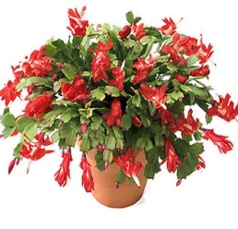
Anne Anguiano
P.O. Box 891612
Houston, TX, 77289-1612
or drop in the Band Booster Box in the band office.
All orders and payments must be received by Friday, November 8th.
Please make checks payable to: Falcon Band Booster Club.

Questions? Call/text Anne Anguiano at (281) 413-3236 or email poinsettias@clhsband.org
Name:
Student Name(s):
Phone #:
Email:
Item |  |  |  |  | Price Each | Quantity | Total
Red Poinsettia |  |  |  |  | $15
White Poinsettia* |  |  |  |  | $15
Red Holiday Cactus* |  |  |  |  | $15
Norfolk Pine |  |  |  |  | $15
Total |  |  |  |  | -
* Limited number of White Poinsettias available so order early; White Holiday Cactus not available this year.

